Flyweight Pattern
# Source: AI Source: Provided by: [Data Path: Persons Table -> ID Column: 1, Name_En Column: Motasem Essam] -> From: [ChatGPT] on [1/23/2026]
The Flyweight Pattern is used to reduce memory usage by sharing as much data as possible between similar objects.
👉 Think of it like trees in a forest: instead of storing full data for every tree, you store shared data (type, texture) once, and only unique data (position) separately.

🔑 Key Points
# Source: AI Source: Provided by: [Data Path: Persons Table -> ID Column: 1, Name_En Column: Motasem Essam] -> From: [ChatGPT] on [1/23/2026]
• Shares common (intrinsic) state across objects
• Separates intrinsic (shared) and extrinsic (unique) data
• Useful when creating large numbers of similar objects
• Optimizes memory and performance

❌ Bad Example
# Source: AI Source: Provided by: [Data Path: Persons Table -> ID Column: 1, Name_En Column: Motasem Essam] -> From: [ChatGPT] on [1/23/2026]
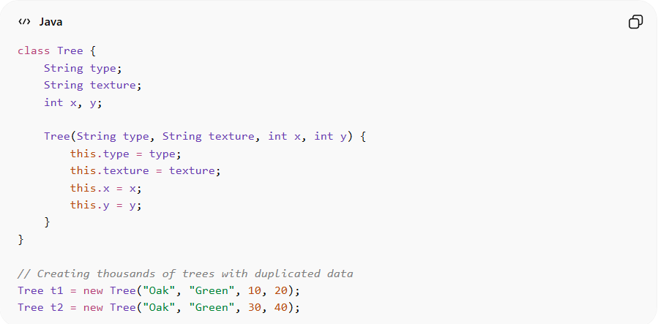
class Tree {
String type;
String texture;
int x, y;

Tree(String type, String texture, int x, int y) {
this.type = type;
this.texture = texture;
this.x = x;
this.y = y;
}
}

// Creating thousands of trees with duplicated data
Tree t1 = new Tree("Oak", "Green", 10, 20);
Tree t2 = new Tree("Oak", "Green", 30, 40);
Problems:
• Repeated storage of same data (type, texture)
• High memory consumption
• Inefficient for large-scale systems

✅ Good Example
# Source: AI Source: Provided by: [Data Path: Persons Table -> ID Column: 1, Name_En Column: Motasem Essam] -> From: [ChatGPT] on [1/23/2026]
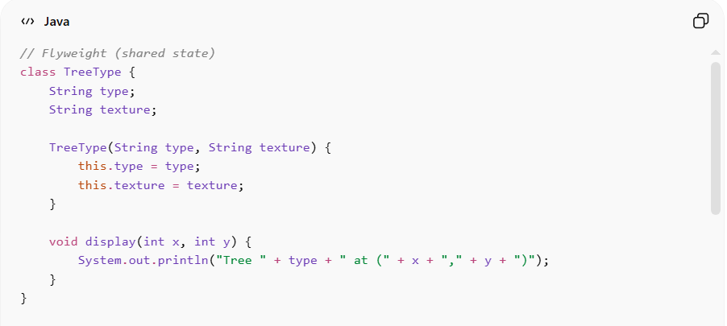
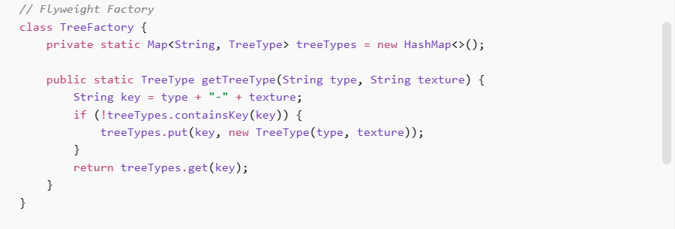
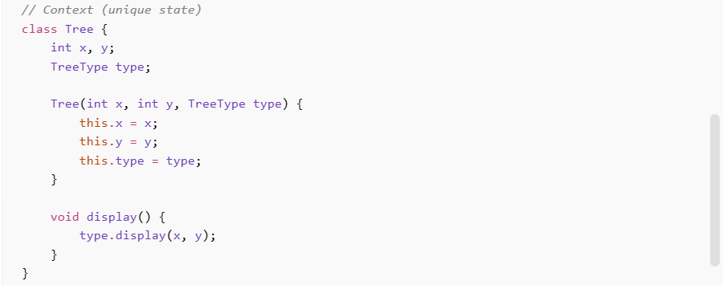
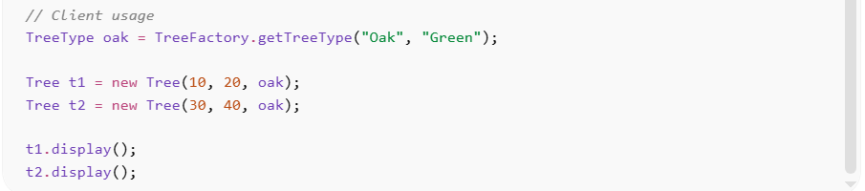
// Flyweight (shared state)
class TreeType {
String type;
String texture;

TreeType(String type, String texture) {
this.type = type;
this.texture = texture;
}

void display(int x, int y) {
System.out.println("Tree " + type + " at (" + x + "," + y + ")");
}
}

// Flyweight Factory
class TreeFactory {
private static Map<String, TreeType> treeTypes = new HashMap<>();

public static TreeType getTreeType(String type, String texture) {
String key = type + "-" + texture;
if (!treeTypes.containsKey(key)) {
treeTypes.put(key, new TreeType(type, texture));
}
return treeTypes.get(key);
}
}

// Context (unique state)
class Tree {
int x, y;
TreeType type;

Tree(int x, int y, TreeType type) {
this.x = x;
this.y = y;
this.type = type;
}

void display() {
type.display(x, y);
}
}

// Client usage
TreeType oak = TreeFactory.getTreeType("Oak", "Green");

Tree t1 = new Tree(10, 20, oak);
Tree t2 = new Tree(30, 40, oak);

t1.display();
t2.display();
Benefits:
• Significant memory savings
• Efficient handling of large numbers of objects
• Promotes reuse of shared data
• Improves performance in large systems

⚡ Advantages
# Source: AI Source: Provided by: [Data Path: Persons Table -> ID Column: 1, Name_En Column: Motasem Essam] -> From: [ChatGPT] on [1/23/2026]
• Reduces memory consumption
• Improves performance for large datasets
• Encourages data sharing and reuse
• Useful for resource-intensive applications

⚠️ Disadvantages
# Source: AI Source: Provided by: [Data Path: Persons Table -> ID Column: 1, Name_En Column: Motasem Essam] -> From: [ChatGPT] on [1/23/2026]
• Increases code complexity
• Requires careful separation of intrinsic vs extrinsic state
• Debugging can be more difficult
• May introduce runtime overhead for managing shared objects

🛠️ Use Cases
# Source: AI Source: Provided by: [Data Path: Persons Table -> ID Column: 1, Name_En Column: Motasem Essam] -> From: [ChatGPT] on [1/23/2026]
• Game development – rendering thousands of similar objects (trees, bullets)
• Text editors – sharing character formatting (fonts, styles)
• Graphics systems – shapes with shared properties
• Caching systems – reusing frequently used objects

